Given a n-ary tree, find its maximum depth.

The maximum depth is the number of nodes along the longest path from the root node down to the farthest leaf node.

*Nary-Tree input serialization is represented in their level order traversal, each group of children is separated by the null value (See examples).*

**Example 1:**

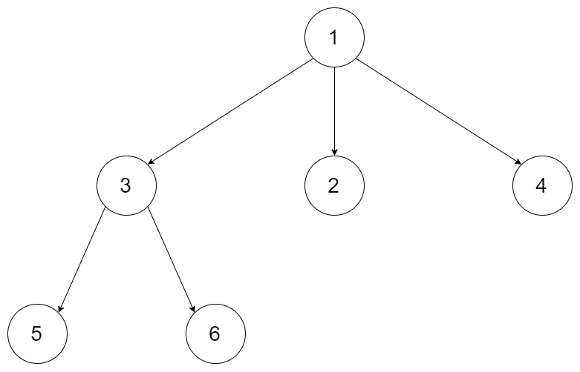

**Input:** root = [1,null,3,2,4,null,5,6]

**Output:** 3

**Example 2:**

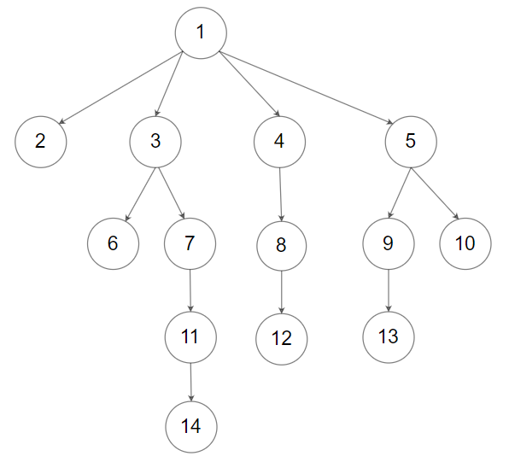

**Input:** root = [1,null,2,3,4,5,null,null,6,7,null,8,null,9,10,null,null,11,null,12,null,13,null,null,14]

**Output:** 5

**Constraints:**

* The depth of the n-ary tree is less than or equal to 1000.
* The total number of nodes is between [0, 10^4].